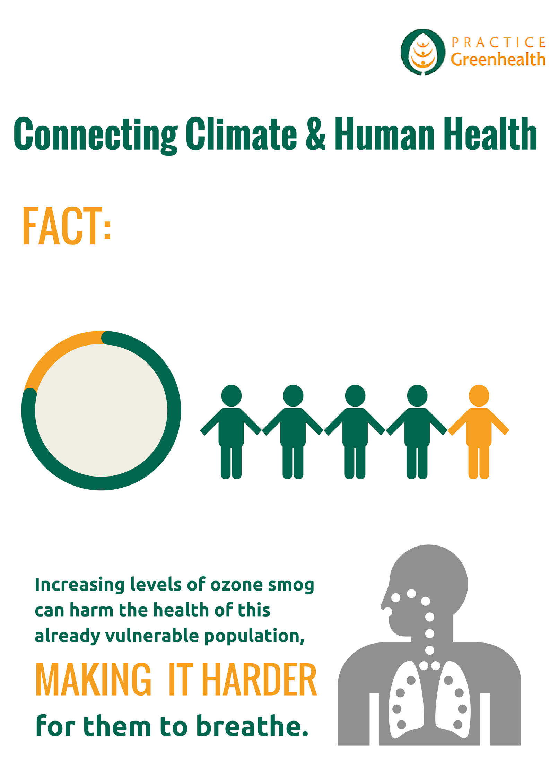

Insert total asthma cases as a percentage of your state’s total population.

% of population

Insert the number of asthma cases in your state.