Anatomy of a Green Team
This table shows side by side comparison of various size hospitals and health systems and how they structure their sustainability committee activities.
Team Structure and Details | Memorial Sloan Kettering Cancer Center (MSK) | University of Chicago Medical Center | Providence St. Joseph Health | HealthPartners
Locations that are encompassed in committee activities | One committee covers all MSK sites including New York City network and regional locations. Off sites that are included are laboratories, ambulatory and outpatient care sites. | As an academic medical center, there are multiple facilities but they are considered and treated as one hospital. Thus there is one committee that covers all locations: Comer Children's Hospital, Center for Care and Discovery Hospital, Mitchell Hospital, and various outpatient clinics | A regional committee known as ACES (Action Collaborative for Environmental Stewardship) that covers the Pacific Northwest, Montana, California, New Mexico and Texas. | 1 Enterprise steering committee  6 Hospital Green Teams  2 Admin Green Teams  1 Enterprise Clinic Green Team  6 Individual Clinic Green Teams
What is the structure of the team at one site? | The Green Team is the central institutional committee responsible for identifying and implementing sustainability initiatives that reduce the environmental impacts of day to day operations. Each Green Team Committee member represents a prioritized department or function and works in conjunction with Sustainability staff to identify opportunities in line with the Committee’s mission statement, raise awareness, and encourage staff participation. | There is only one green team which represents all of those facilities, and includes a mix of operational leaders and passionate employees. | Each local site green team is encouraged to have cross functional representation. The aim, as denoted from the name, is to collaborate with peers inspiring actionable steps towards environmental stewardship. Representatives from each site report through ACES’s monthly meeting to learn of ongoing efforts, barriers and overall success stories while sharing immediate internal resources as well as ones from Practice Greenhealth. The formal monthly meeting features a “State of the Green Team” report from a hospital or region as well as a specific monthly educational topic. | Each green team is comprised of a combination of subject matter experts (e.g., housekeeping, facilities, OR, etc.) and passionate volunteers. Each green team has an executive sponsor, a leader and a member of the enterprise sustainability department present or at least available as a resource.
How do multiple sites engage in green team activity? | A key Outpatient Administrator is the primary representative on institutional Green Team and acts as a liaison for MSK’s outpatient sites. The staff engagement sub-committee helps coordinate volunteer “GreenReps” (staff extensions of the Green Team across MSK) which has 100% representation from all sites and major departments. The OneMSK intranet houses resources on prioritized initiatives allowing empowered staff to work locally to advance sustainability at MSK. | NA | As sites become more closely aligned with system-level short term and long term goals, ACES helps to engage hospitals and multiple sites by meeting them where they are and allowing them to voice their barriers and success stories. The more internal collaboration that is experienced, the more common resources are shared to help push best practices. | The enterprise clinic green team brings together representatives from 70 clinics; and the Bloomington Admin green team has representatives from 4 admin buildings in the vicinity of the lead administrative office. Both green teams meet quarterly.  All green teams are represented at the enterprise steering committee, which meets monthly.
How does the green team communicate its activities? To whom? How often i.e. leadership team, all staff, other key committees like community benefit, safety, environment of care or others. | Sustainability goals are included in Hospital Administration’s annual institutional goals. Progress on annual goals is presented to all sustainability-related and leadership committees. Progress metrics, key initiative details and the Annual Sustainability Report are available to all staff via the OneMSK (intranet) Sustainability site. Communications throughout the year via monthly Green Team meetings, sub-committee meetings, the intranet newsfeed and pages, printed communications (e.g. signs, posters), fairs in cafeterias/staff lounges, presentations to key committees (e.g. steering committees, product evaluation committees, etc.) and direct communication to relevant staff or departments to drive targeted initiatives. | The main channel of communication is through email distribution to the green team members, but they are working to get this information on the intranet site with monthly updates.  As for leadership updates, the executive champion includes monthly reports that to the COO. | Thanks to the reporting structure, information is funneled from the front lines to the Sustainability Coordinator and chair who acts as a catalyst with senior leadership and the corresponding ministries/regions. This occurs on a monthly basis with intermittent communications internally. The work is also managed and tied to a strategic framework that formally addresses environmental sustainability which includes numerous senior leaders and management (see goals for more details). | The enterprise has a five year plan and an annual work plan. (see web page)  Each green team also has an annual work plan.
Who is on the team and who is chair | Senior management staff representing a range of departments across MSK, including Hospital Administration, Facilities Operations, Design and Construction, Supply Chain & Procurement, Food & Nutrition Services, Human Resources, Public Affairs, Surgery, Sloan Kettering Institute (SKI) Administration, Environmental Services and Sustainability. Committee Chair is an SVP of Hospital Administration and the Vice Chair is the VP of Facilities Operations. | The Director of Environmental Services, Jay Patel, is the chair of the team. The rest of the team is a good representation of operational departments: Purchasing, a Process Improvement Manager in Surgical Services, a rep from Stericycle, Human Resources, Staff Nurses from various areas, Director of Volunteer Services, Building Director and Engineer from Facilities, a Business Operations Manager, Supervisor of Central Sterile Processing, Interior Designer, Manager of Anesthesia Support Services, the Senior Operations Manager for Parking Services, and other members that are passionate about environmental stewardship. | The system Chief Environmental Officer Richard Beam sits as an executive sponsor while Beth Shenk, sustainability coordinator, is the chair and is a well known clinician and sustainability champion internally and externally. Beth is both a Nurse Scientist and Sustainability Coordinator based at St. Patrick Hospital in Montana. Beth also authored Nurses’ Environmental Awareness Tool (NEAT) and is the found of their hospital’s Green 4 Good program.  The remaining members on ACES range from all departments and varying positions. A typical monthly webinar has solid participation levels with attendees that range above 20. | Subject/department experts/leaders and passionate volunteers. The green team leader is a mid-level management staff person.
Meeting frequency and time | Monthly for 1 hour | Monthly for 1 hour | Monthly since 2008, meetings last one hour, by Lync. | Most meet monthly, some quarterly.
Has the team set measurable goals? | Goals have been set for greenhouse gas emissions reduction, water conservation, paper reduction, staff engagement, waste (recycling and RMW generation rates) and green building design standards. | Action plan created through the Lean Process Improvement:  - 27% recycling goal  - Retrain staff and fully implement segregation in public areas for recycling and waste  - Marketing / signage for recycling  - Creating the intranet page to market these efforts  - Working with the wellness team to incorporate sustainability initiatives  - Adding sections of sustainability to the annual competency review (Computer Based Learning)  - Installing dimmers for OR lights | The overall objective is to reduce and mitigate environmental impacts. The regional committee is tied to a greater organizational initiative to reduce its environmental footprint through key targeted short term goals (12-18 months) that includes leadership development, aligning the stewardship of key services to long term goals that enable a more focused EPP, an implemented water reduction plan and making energy conservation part of the culture while continuing to reduce use of and investment in fossil fuels. | All work plans have assigned personnel and deadlines.
Any Mission Language or other policy? | Mission Statement: Sustainability initiatives at MSK focus on reducing our impact on the environment. We work to reduce our energy use, material consumption, and waste and to create a healthy environment for our patients, staff, and community. | The Go Green Committee Mission: To create a sustainability vision and identify short and long term goals for the organization that will align with the AOP and make our institution an environmentally responsible one. | “We Strive to Care Wisely for our People, our Resources and our Earth.”  In 2016, Providence St. Joseph Health CEO Rodney Hochman wrote a letter to the entire organization entitled “How do you protect the environment” where he emphasized a commitment to carbon neutrality and outlined a strategic framework that described overarching targets including a reduction of GHG emissions of 30% by 2025. The letter ends with empowering employees to take their turn and share ideas and stories around stewardship. | HealthPartners updated its Environmental Stewardship Commitment Statement in 2016.  “ HealthPartners is committed to caring for the places where we live and work so we can provide a healthier and cleaner community for our employees, members, patients and future generations.”
Logo, name or other details |  |  | ACES: Action Collaborative for Environmental Stewardship | 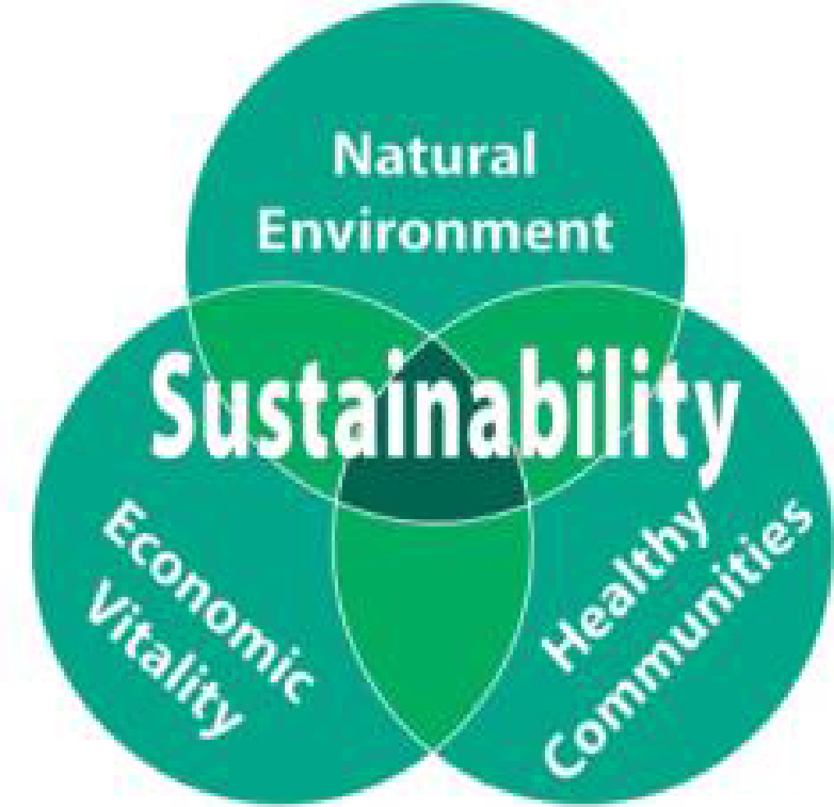
Challenges of Team | Creating consistency for sustainability-related activities/initiatives across MSK’s growing number of sites; keeping 170+ GreenReps engaged in sustainability activities; avoiding scheduling conflicts for meeting attendance; prioritizing limited resources to manage the growth of the Sustainability Program; providing adequate green space in an urban environment; and, ensuring our efforts are consistently aligned with MSK’s growth strategy and stakeholder priorities. | Focus and understanding what is practical to move forward on. Starting first with simple things with a big impact. | Scale and organizational size: Providence St. Joseph Health is the resulting combination of two large health systems, and now includes over 106,000 caregivers across 50 hospitals, 829 clinics, and 23,000 physicians. Tackling sustainability systemically can be a challenge with growing organizations and PSH is positioned with a strategic framework to tackle it head on while using ACES as one of its deployment arms in reducing its environmental footprint. This also means that continuously engaging employees and creating a culture of sustainability is at the forefront and a hopeful outcome of this meaningful work. | Time is a challenge. We have moved beyond the low hanging fruit phase of our program so many of our new goals are more complicated and some require resources.
What’s going well with Team | Consistently meeting targeted goals; increased recognition from executive leadership; increased staff engagement and participation; and, increased breadth of goals and initiatives. | Good engagement and participation is happening on the green team - people are ready for action. | Organization silos are breaking down as more and more monthly meetings introduce new members and success stories. The celebrations from projects/initiatives become real achievements that are felt amongst attendees and instant networking is made as participants do Q&A in real time to get deeper understanding. The overall flow of the educational sessions have been animated with presenters being prepared in advance thanks to the help of the structure and chair. | Engagement is off the charts. The team has tied the program to the mission which makes the commitment easier to understand.

