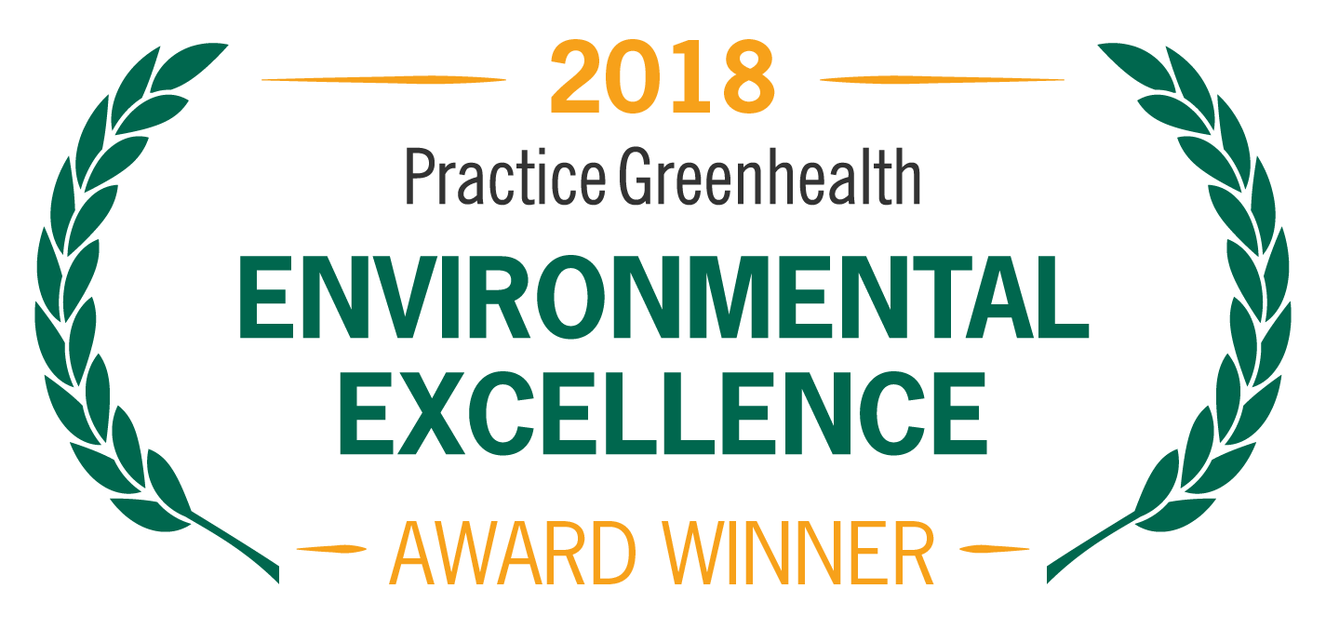
Organization’s Logo

FOR IMMEDIATE RELEASE Contact: Name
Date Phone

<ORGANIZATION NAME> RECEIVES NATIONAL AWARD FOR SYSTEM-WIDE ENVIRONMENTAL STEWARDSHIP

Practice Greenhealth System for Change Award honors health systems leading the nation in sustainability

(CITY, STATE)—In recognition for standard-setting sustainability achievements, <Organization Name> received a System for Change Award from Practice Greenhealth, the nation’s leading organization dedicated to environmental sustainability in health care. The award is one of the Environmental Excellence Awards given each year to honor environmental achievements in the health care sector.

The System for Change Award recognizes health systems that are working cohesively and across hospitals and facilities to set and meet goals related to sustainability, from reducing energy use to increasing recycling to establishing green building practices. System for Change Award winners have at least four acute-care hospitals and have demonstrated cohesive and effective strategies to achieve sustainability.

< ADD DETAILS ABOUT PROGRAMS & ACHIEVEMENTS LEADING TO AWARD >

SAMPLE QUOTE FROM ORGANIZATION: “As a system, <Organization Name> strives to make a difference in our communities by reducing our environmental impact and emphasizing sustainable practices,” said <Organization Spokesperson>. “Sustainability is at the heart of our healing mission, allowing us to better care for our patients, our communities and the planet.”

The award will be presented at the Practice Greenhealth Environmental Excellence Awards Gala, set for May 9th in San Diego at the conclusion of the CleanMed Conference & Exhibition.

About Company

About Practice Greenhealth
Practice Greenhealth is the nation’s leading health care community dedicated to transforming health care worldwide so that it reduces its environmental footprint, becomes a community anchor for sustainability and a leader in the global movement for environmental health and justice. To learn more about Practice Greenhealth visit www.practicegreenhealth.org.

# # #

