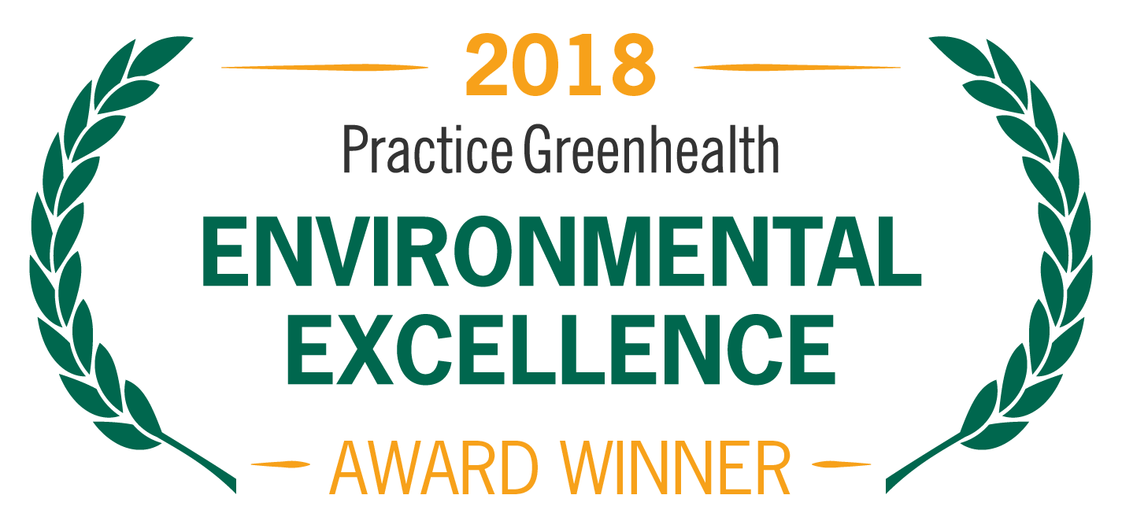
Organization’s Logo

FOR IMMEDIATE RELEASE Contact: Name
Date Phone

<Organization Name> RECEIVES NATIONAL AWARD FOR SUSTAINABILITY, WASTE REDUCTION

Practice Greenhealth Partner Recognition Award honors emerging leaders in environmental stewardship

(CITY, STATE)–In recognition for achievements in sustainability and waste reduction, <Organization Name> received a Partner Recognition Award from Practice Greenhealth, the nation’s leading organization dedicated to environmental sustainability in health care. The award is one of the Environmental Excellence Awards given each year to honor environmental achievements in the health care sector.

The award is given to health care facilities that are changing their practices to become more sustainable and have achieved progress in areas such as waste reduction, renewable energy adoption, food purchasing and mercury elimination. They also must have a recycling rate of at least 10 percent for their entire waste stream.

< ADD DETAILS ABOUT PROGRAMS & ACHIEVEMENTS LEADING TO AWARD >

SAMPLE QUOTE FROM ORGANIZATION: “As health care providers, sustainability is at the core of our healing mission and central to protecting the health of our patients, staff and community,” said < Name, Title, Organization >. “We look forward to working with Practice Greenhealth to make our practices even more sustainable.”

The award will be presented at the Practice Greenhealth Environmental Excellence Awards Gala, set for May 9th in San Diego at the conclusion of the CleanMed Conference & Exhibition.

About <Organization>

About Practice Greenhealth
Practice Greenhealth is the nation’s leading health care community dedicated to transforming health care worldwide so that it reduces its environmental footprint, becomes a community anchor for sustainability and a leader in the global movement for environmental health and justice. To learn more about Practice Greenhealth visit www.practicegreenhealth.org.
###

