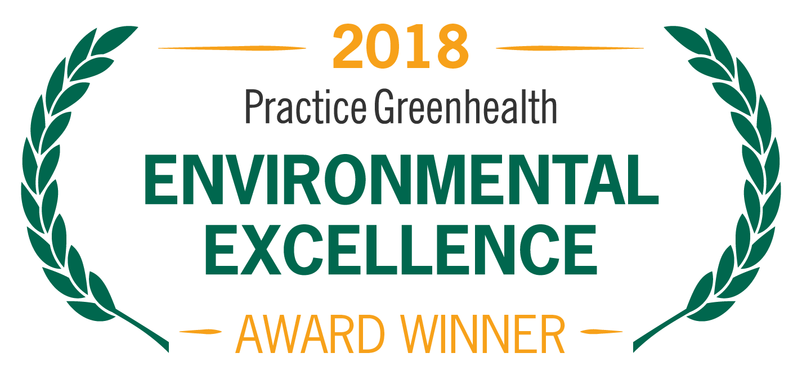
Organization’s Logo

FOR IMMEDIATE RELEASE Contact: Name
Date Phone

<Name of Organization> RECEIVES NATIONAL AWARD FOR ACHIEVEMENTS IN SUSTAINABILITY

Practice Greenhealth Partner for Change Award honors superior performance in environmental stewardship

(CITY, STATE)—In recognition for successful programs to reduce their environmental impact, <Organization Name> received the Partner for Change Award from Practice Greenhealth, the nation’s leading organization dedicated to environmental sustainability in health care. The award is one of the Environmental Excellence Awards given each year to honor environmental achievements in the health care sector.

The Partner for Change Award recognizes health care facilities that continuously improve and expand upon programs to eliminate mercury, reduce and recycle waste, source products sustainably, and more. Winning facilities must demonstrate that they are recycling at least 15 percent of their total waste, have reduced regulated medical waste, are on track to eliminate mercury, and have developed successful sustainability programs in many areas.

< ADD DETAILS ABOUT PROGRAMS & ACHIEVEMENTS LEADING TO AWARD >

SAMPLE QUOTE FROM ORGANIZATION: “As health care providers, sustainability is at the core of our healing mission and central to protecting the health of our patients, staff and community,” said <Name, Title, Organization>. “We take pride in our sustainability programs and the positive impacts they have on the environment and the communities we serve.”

The award will be presented at the Practice Greenhealth Environmental Excellence Awards Gala, set for May 9th in San Diego at the conclusion of the CleanMed Conference & Exhibition.

About <Company>

About Practice Greenhealth
Practice Greenhealth is the nation’s leading health care community dedicated to transforming health care worldwide so that it reduces its environmental footprint, becomes a community anchor for sustainability and a leader in the global movement for environmental health and justice. To learn more about Practice Greenhealth visit www.practicegreenhealth.org.

###

