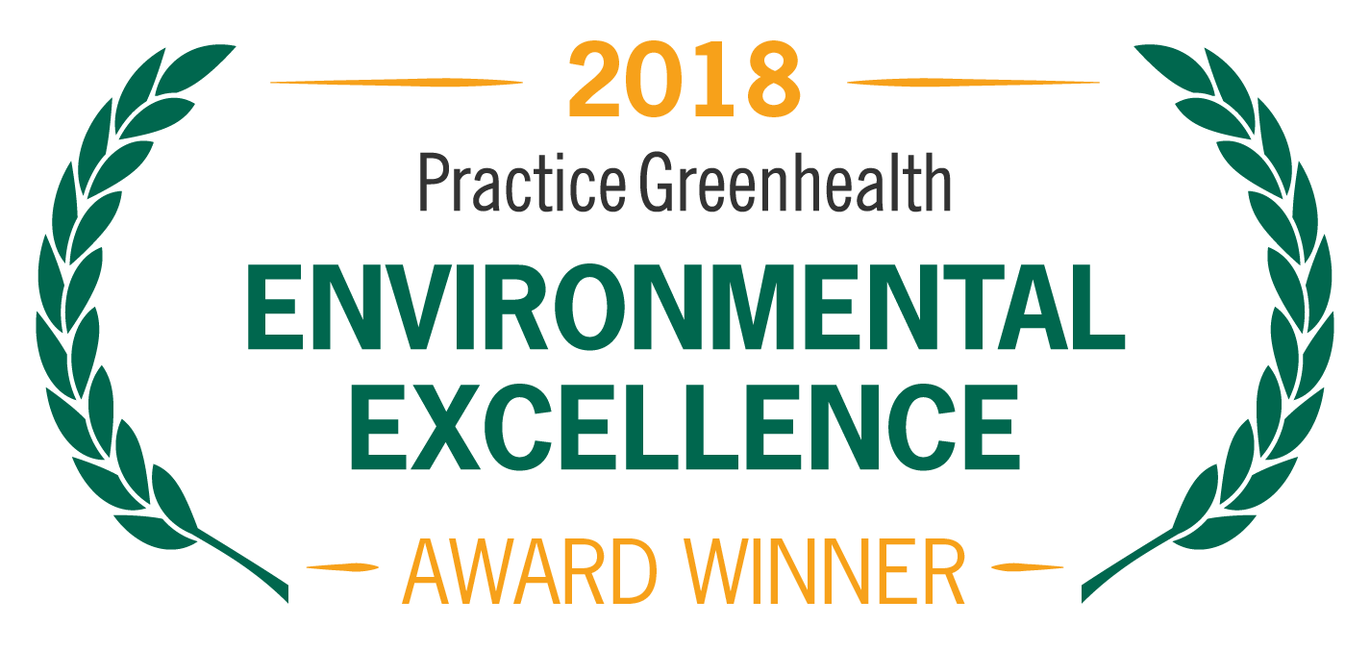
Organization’s Logo

FOR IMMEDIATE RELEASE
Contact: Name
Date Phone

<ORGANIZATION NAME> WINS NATIONAL AWARD FOR ELIMINATING MERCURY FROM FACILITY

Practice Greenhealth Making Medicine Mercury-Free Award honors removal of one of health care’s most hazardous chemicals

(CITY, STATE) – In recognition for successful efforts to eliminate mercury, <Organization> received a Making Medicine Mercury-Free Award from Practice Greenhealth, the nation’s leading organization dedicated to environmental sustainability in health care. The award is one of the Environmental Excellence Awards given each year to honor environmental achievements in the health care sector.

The award is given to health care facilities that have virtually eliminated mercury and have policies in place to prevent it from re-entering the facility. Award criteria include strong mercury-free purchasing policies and management practices, staff education, and a commitment to continuing to be mercury-free. Mercury is one of the most hazardous chemicals, associated with many health risks.

< ADD DETAILS ABOUT PROGRAMS & ACHIEVEMENTS LEADING TO AWARD >

SAMPLE QUOTE FROM ORGANIZATION “Eliminating mercury from the products we use protects both our patients and staff,” said < Name, Title, Organization >. “We are proud of our successes in eliminating mercury and are committed to doing even more to reduce exposure to this harmful chemical.”

The award will be presented at the Practice Greenhealth Environmental Excellence Awards Gala, set for May 9th in San Diego at the conclusion of the CleanMed Conference & Exhibition.

About <Organization>

About Practice Greenhealth
Practice Greenhealth is the nation’s leading health care community dedicated to transforming health care worldwide so that it reduces its environmental footprint, becomes a community anchor for sustainability and a leader in the global movement for environmental health and justice.. For more information on Practice Greenhealth, visit www.practicegreenhealth.org.

###

