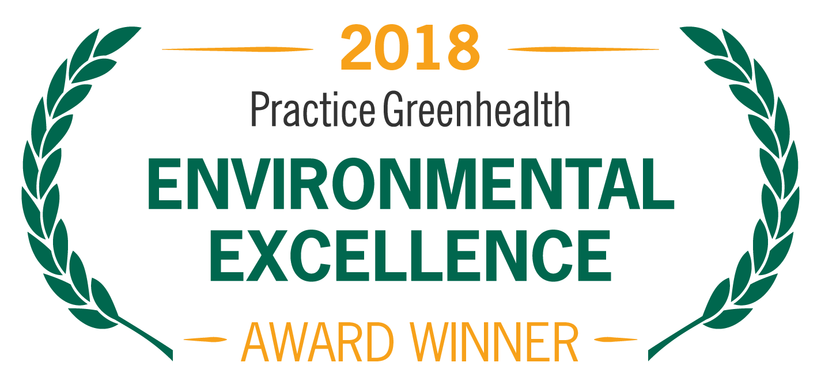
Organization’s Logo

FOR IMMEDIATE RELEASE Contact: Name
Date Phone

<Name of Organization> RECEIVES NATIONAL AWARD FOR ENVIRONMENTAL INNOVATION IN THE OPERATING ROOM
Practice Greenhealth Greening the OR Award honors nationwide leader in sustainability in surgical practices

(CITY, STATE)—In recognition for standard-setting innovation and environmental stewardship, <Organization Name> received this year’s Greening the OR Award from Practice Greenhealth, the nation’s leading organization dedicated to environmental sustainability in health care. The award is one of the Environmental Excellence Awards given each year to honor environmental achievements in the health care sector.

The Greening the OR Award recognizes the facility demonstrating the most success in reducing the environmental impact of its surgical suites. Operating rooms are large contributors to a health care facility’s environmental footprint, creating opportunity for significant cost savings and sustainability improvements..

< ADD DETAILS ABOUT PROGRAMS & ACHIEVEMENTS LEADING TO AWARD >

SAMPLE QUOTE FROM ORGANIZATION: “We are committed to environmentally sound health care and to ensuring the well-being and safety of our patients, staff and community,” said < Name, Title, Organization> “We are proud to be recognized as the nation’s leader in driving the greening of ORs across the country.”

The award will be presented at the Practice Greenhealth Environmental Excellence Awards Gala, set for May 9th in San Diego at the conclusion of the CleanMed Conference & Exhibition.

About <Organization>

About Practice Greenhealth
Practice Greenhealth is the nation’s leading health care community dedicated to transforming health care worldwide so that it reduces its environmental footprint, becomes a community anchor for sustainability and a leader in the global movement for environmental health and justiceTo learn more about Practice Greenhealth visit www.practicegreenhealth.org.

# # #

