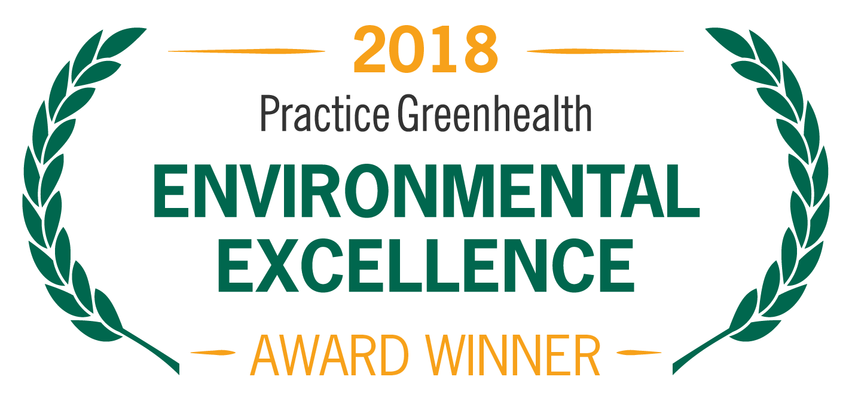
Organization’s Logo

FOR IMMEDIATE RELEASE Contact: Name
Date Phone

<Name of Organization> RECEIVES NATIONAL AWARD FOR EXCELLENCE AND INNOVATION IN SUSTAINABILITY

Greenhealth Emerald Award honors hospitals driving the health care sector toward a greener, healthier future

(CITY, STATE)—In recognition for leading the health care industry in sustainability and environmental stewardship, <Organization Name> received the prominent Greenhealth Emerald Award from Practice Greenhealth, the nation’s leading organization dedicated to environmental sustainability in health care. The award is one of the Environmental Excellence Awards given each year to honor environmental achievements in the health care sector.

The Greenhealth Emerald Award recognizes health care facilities that are setting the standard in eliminating mercury, reducing and recycling waste, sustainable sourcing, and other areas. Winning hospitals have demonstrated a strong commitment to sustainability and shown leadership in the local community and in the health care sector.

< ADD DETAILS ABOUT PROGRAMS & ACHIEVEMENTS LEADING TO AWARD >

SAMPLE QUOTE FROM ORGANIZATION: “As health care providers, sustainability is at the core of our healing mission and central to protecting the health of our patients, staff and community,” said < Name, Title, Organization>. “We look forward to continuing this work to drive the future of health care toward sustainability.”

The award will be presented at the Practice Greenhealth Environmental Excellence Awards Gala, set for May 9th in San Diego at the conclusion of the CleanMed Conference & Exhibition.

About <Organization>

About Practice Greenhealth
Practice Greenhealth is the nation’s leading health care community dedicated to transforming health care worldwide so that it reduces its environmental footprint, becomes a community anchor for sustainability and a leader in the global movement for environmental health and justice. To learn more about Practice Greenhealth visit www.practicegreenhealth.org.

# # #

