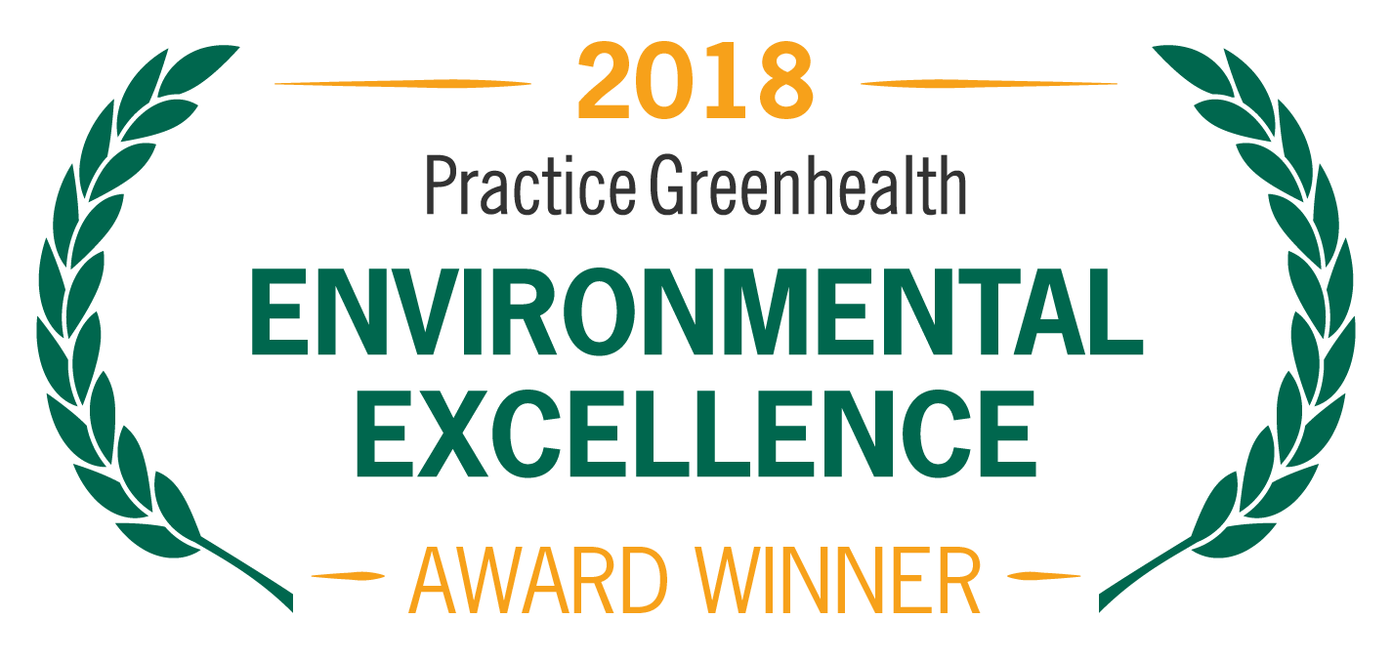
Organization’s Logo

FOR IMMEDIATE RELEASE Contact: Name
Date Phone

<ORGANIZATION NAME> RECOGNIZED AS AMONG MOST SUSTAINABLE HEALTH CARE FACILITIES IN AMERICA

Practice Greenhealth Circles of Excellence Award honors <Organization> among top 10 in <category> category

(CITY, STATE) – In recognition for outstanding accomplishments in sustainability, <Organization> received the Circles of Excellence Award in <CATEGORY> from Practice Greenhealth, the nation’s leading organization dedicated to environmental sustainability in health care. The award is one of the Environmental Excellence Awards given each year to honor environmental achievements in the health care sector.

The award honors hospitals for outstanding performance in one specific area, such as reducing use of toxic chemicals or sourcing food sustainably. These awards highlight hospitals that are pushing the envelope and driving innovation in sustainability performance in each sustainability category. There can be up to 10 designees selected for each Circle of Excellence category.

<CHOOSE ONE OF THE PARAGRAPHS BELOW BASED ON CATEGORY WON>
The Leadership category honors hospitals demonstrating excellence in supporting a long-term commitment to healthier environments through committee structure, reporting, data tracking, communication and education.

The Chemicals category honors hospitals with sound chemical reduction policies and practices. Winners address toxicity through greener cleaning programs and avoidance of chemicals of concern in purchasing products, services and equipment. Elimination of mercury and staff education on hazardous chemicals are paramount.

The Less Waste category honors hospitals that have excelled in waste prevention and material handling, as demonstrated through high recycling rates, low regulated medical waste generation and low rates of total waste generated per patient day. These programs address all facets of the complex health care waste stream.

The Greening the OR category honors hospitals for leadership in implementation and innovation in the surgical department. Winners have demonstrated innovative approaches to waste minimization, clinical plastic recycling, reformulation of operating room kits, single-use device reprocessing, use of reusable sterilization cases, and a range of other programs and associated metrics

The Healthy Food category highlights leaders in sustainable food services, including meat and sugar-sweetened beverage reduction, healthier meat procurement, local sourcing, food waste prevention and management. Top contenders have written policies and an educational strategy that addresses the food system as a critical component in an overall sustainability plan—for human and planetary health.

The Environmentally Preferable Purchasing category celebrates the best in environmentally preferable purchasing programs. Facilities are evaluated on their supporting policies, interactions with suppliers, environmentally preferable contracts and use of environmental attributes in RFPs and business reviews.

The Energy category celebrates hospitals that are leading the sector in energy efficiency and strategic energy use planning. Leaders generally have energy managers and written programs to reduce energy use over time. They are tracking energy use intensity and ENERGY STAR performance metrics and sharing details on comprehensive project implementation and staff engagement strategies.

The Water category recognizes hospitals for exemplary programs in water conservation and efficiency. These early adopters boast fewer gallons of water consumption per square foot, tracking of implemented conservation projects, written plans to reduce water consumption over time and have water-tracking mechanisms in place.

The Climate category highlights visionary hospitals taking the lead on tracking and measuring carbon emissions and developing overall climate programs. Winning hospitals demonstrate an understanding of the health impacts of climate change and are acting to mitigate those impacts and educate their staff and communities on playing a supporting role.

The Green Building category is presented to hospitals that have demonstrated LEED and other green building achievements over the past five years. These hospitals emphasize policies that show a commitment to or even requirement of LEED-level construction standards for all major new builds or renovations. Their achievements include energy and water efficiency, safer materials, regional sourcing, integration of nature and other mechanisms to create high-performance healing environments.

SAMPLE QUOTE FROM ORGANIZATION: “<Organization Name> has been demonstrating leadership in our community and the health care sector in the area of <CATEGORY> to improve the health of our patients, staff, and community,” said <Organization Spokesperson>. “We are proud to be named one of the top 10 hospitals in the country for this work and will continue to make sustainability a top priority.”

< ADD DETAILS ABOUT PROGRAMS & ACHIEVEMENTS LEADING TO AWARD >

The award will be presented at the Practice Greenhealth Environmental Excellence Awards Gala, set for May 9th in San Diego at the conclusion of the CleanMed Conference & Exhibition.

About Organization

About Practice Greenhealth
Practice Greenhealth is the nation’s leading health care community dedicated to transforming health care worldwide so that it reduces its environmental footprint, becomes a community anchor for sustainability and a leader in the global movement for environmental health and justice. To learn more about Practice Greenhealth visit www.practicegreenhealth.org.

# # #

