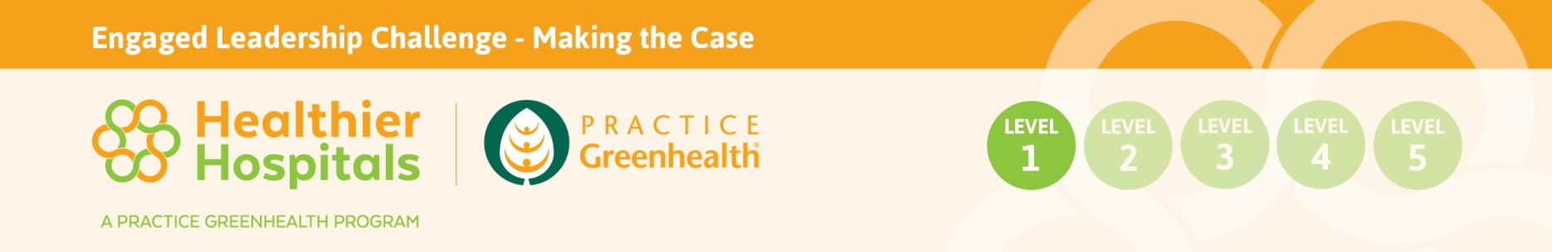
“Making the Case” Worksheet
Fill out this worksheet to capture the uniqueness of the organization, its drivers, leverage points and other strategic priorities. The content of this exercise is necessary to build the value proposition.
Background and Strategy
Name of Organization:

Mission:

Vision:

Core Values:

What type of care is the hospital or system known for (i.e. cardiac care, cancer etc.)?

Does the facility have a strategic plan? Yes No
If yes, list its top 5 priority areas:

Does the President/CEO have an area of focused passion? i.e. patient experience, risk avoidance, quality, community, research. Don’t be limited by one - list them!

Regional Efforts - Does the region have any environmental goals or other leverage opportunities?
(Check with local municipality, state or region)

Name top three competing health systems:

Ask facilities lead about the local utility and find out if there are regional incentives for energy upgrades.

Are there any teaching institutions in the region to partner on sustainability internships (health care administration, master’s in business administration, public health, engineering, nutrition or sustainability programs)?
List institutions here and key degree:

Awards received in past three years:

Provide list of board members and their affiliation/background (if available):

Does the facility have a community benefit report? Yes No
If yes, what are key community health needs identified in the report:

Does the facility have an annual report? Yes No
If yes, what are the five key messages of the report?

Does the facility conduct research? Yes No
Is any of the research connected to health? Yes No
What have we missed? What are other key drivers in making the case to leadership?

