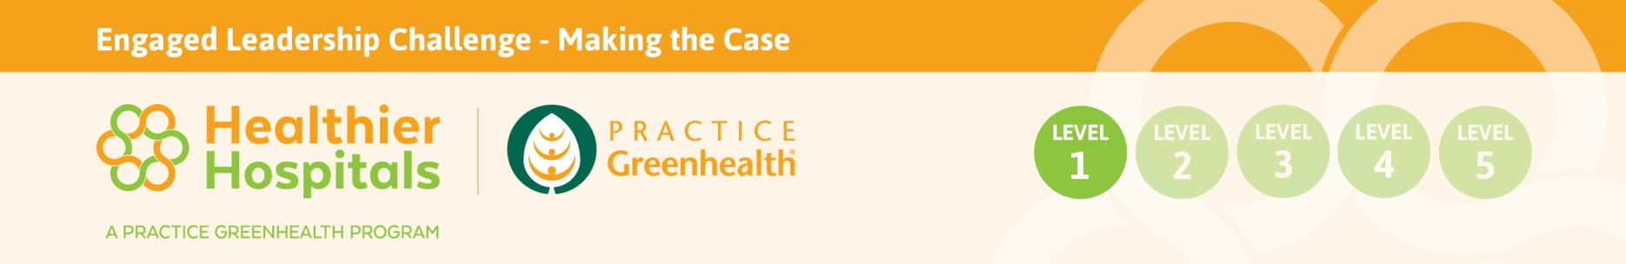
Champion Worksheet
Use this form to identify key stakeholders to flesh out alignment, successes, champions and other lessons-learned to build the case. Key departments are listed with topics that could be used to aid in discussion. Some successes may not be realized unless the conversation is started. For example, some successes may be viewed as standard operating procedure or regulatory compliance. The Discussion Points may help in capturing these activities and making the connection to healthier environments. Even if the success was achieved a few years ago, its value remains - capture it! Use the Sharing Success Worksheet to capture data and story behind each success.
Contact Name, Title,  Email, Phone | Discussion Points to Tease Out Successes | Outcomes  (cost savings, health outcomes, environmental outcomes, safety outcomes, culture, mission demonstration, other measurable outcomes)
Example 1:  Jim Brown, Director of Environmental Services | Implemented a HIPAA compliant recycling program and corrugated box recycling. | Environmental Outcome:  2,500 pounds of corrugated is diverted from the landfill annually.  Regulatory and Environmental Outcome:  HIPAA is a regulatory issue and all of the collected Protected Health Information is recycled - This diverts 1,500 pounds of waste from landfills annually.
Example 2:  Purchasing and supply chain | Waste management, recycling, single use device reprocessing, energy/water conservation, environmentally preferred products and services, green cleaners, building commissioning, electric vehicles, take-back programs and work with Group Purchasing Organizations, to name a few.  What have been challenges in purchasing that sustainability might help accomplish?
Facilities Management & Energy/Water Management | Energy Star or other measurement tool for tracking energy and water performance. Has there been success in energy and water conservation?
Human Resources | Staff engagement, satisfaction and morale, wellness initiatives, staff training, retention
Food and Nutrition | Wellness, healthier food, antibiotics and meat, local and sustainable, food service programs, sugar sweetened beverages, recycling, composting, education
Clinical Leader  (i.e. community health, pediatrics, chief experience officer, CNO, CMO and other prevention experts) | Climate and public health, multi drug resistance, healthier food advocate, prevention, wellness, healthier food, safer materials, energy conservation
Surgical Services | Equipment donation, single use device reprocessing, LED Surgical Lighting, fluid management, red bag minimization, OR air-exchange set back, recycling, water conservation, reusable sterilization cases, red bag reduction.
Environmental Services | Recycling, green cleaning, equipment donation, red bag reduction, spill response
Others to consider:
Ethics
Community Benefit
Safety/Risk/Regulatory Affairs
Environment of Care Committee

